Exercise 1

1) Press the Push Button and observe the Input Status light on the PLC. What

happens to it?

The input status light on X0 turns on and almost immediately the output light Y0 also turns on.

2) As you press the Push Button – what happens to the contact on the screen?

The input X0 turns blue and then the output Y0 turns blue.

3) Press the PB on and off as fast as you can. Does the Input Status light on

the PLC keep up to you?

Yes the lights on the PLC keep up with my button presses.

4) Does the contact on the screen keep pace?

No

Exercise 2

1) Press Push Button (PB) X0 and observe the Input Status light on the PLC.

The Input light X0 turns on.

What happens to it?

2) Does Output Y0 turn on when you press PB X0?

When X0 is turned on Y0 also turns on.

3) What happens when you press PB X1?

The lights X1 and Y0 light up on the PLC and on the screen X1 and both Y0s light up

4) How come PB X0 doesn’t turn on Output Y0?

The program moves down the ladder, so now that X1 has been used it is now the line that is being read. However the input light on the plc turns because it is receiving power but the relay isn’t being turned on.

Exercise 3

1) Give a quick press on PB X0 and release the PB. What happens to output

C0?

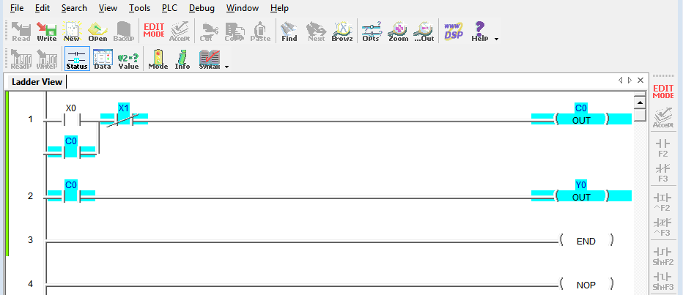

2) What happens to Output Y0?

Y0 is turned on even after X0 is released because it is now checking the status of X1.

3) Now quickly press and release PB X1. What happens to Output C0?

C0 is turned off

4) What happens to Output Y0?

Y0 turns off,

Exercise 4

1) What happens when you press and hold PB X0?

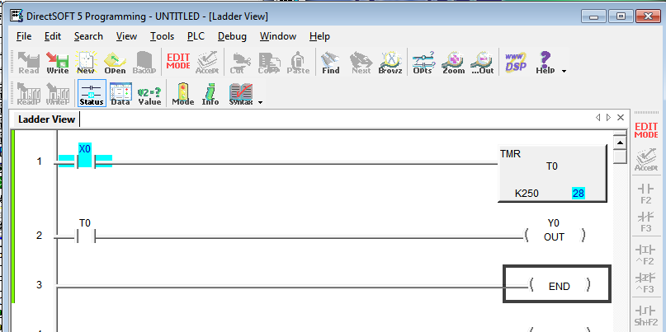

2) What happens when you press PB X0 for just a brief moment?

3) When does Output Y0 turn on?

Challenge:

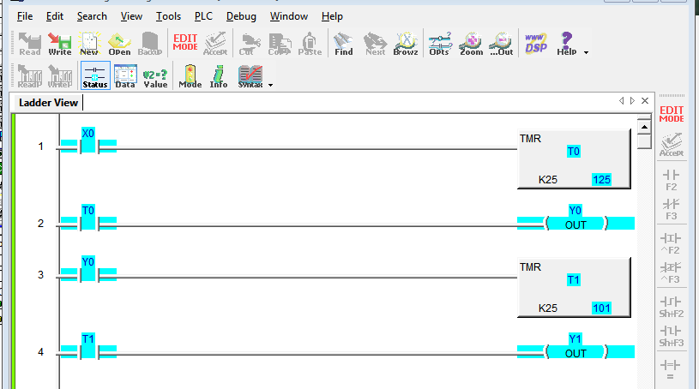

Exercise 5

1) What is the status of output Y0 when you go into the Run Mode?

Y0 is off when the program is first run.

2) Push button X0 3 times, what is the status of YO?

Y0 is still off but the count of K is increased to 3.

3) Push button X1 once, what is the status of Y0?

Y0 is still off and the count is reduced to 0.

4) Push button X0 5 times, what is the status of YO?

Y0 turns on when the counter reaches 5.

5) Push button X0 a few more times, what is the status of Y0?

Y0 remains on as long as the count is higher than 5, which is the chosen input count.

6) Now push button X1 once, what is the status of Y0?

Y0 turns off and the count is reduced to 0.

Exercise 6

1) When you press PB0 (X0) what happens?

2) After pressing PB0 (X0) and then press PB1 (X1), what happens?